RESEARCH PROJECT
Assessment Task 1. – Assessment of Professional Skills
Border College of Natural Therapies.
Faye Ferguson

Showing the effects on the Body of the Bowen Technique using Thermal Imaging.

The purpose of this research was to reveal how Medical Infrared Thermal Imaging and Bowen Therapy join together to show how the body is effected by a Bowen Therapy Treatment. These effects are shown by having the images taken before a treatment and then having images taken several times after a treatment, with a thermography camera.

Thermal Thermography is the use of an infrared thermal imaging and measurement camera to ‘”see” and “measure” thermal energy emitted from an object.

Thermal, or Infrared Energy, is light that is not visible because its wavelength is too long to be detected by the human eye: it’s the part of the electromagnetic spectrum that we perceive as heat. Unlike visible light, in the infrared world, everything with a temperature above absolute zero emits heat. Even very cold objects, like ice cubes, emit infrared radiation. The higher the object’s temperature, the greater the infrared radiation emitted. Infrared allows us to see what our eyes cannot.

Infrared Thermography is being used in every day applications to assess, for instance, how much heat is being lost from a building, how the brakes on a car perform and how quickly skin heals around a wound after an operation. As well as in offices, schools, factories, hotels, construction, workshops and multi-site co-ordination.

Infrared Thermograph is also used in condition monitoring - how well a mechanical system is performing: preventative maintenance - how hot the fuses of a factory electrical switchboard are becoming: Medical thermography – assessing skin temperature: Equine thermography – lameness in horses: Thermal Building Survey – reducing heat loss in buildings.

Australian Workplace Thermal Testing, 2003. www.awtt.com.au/thermalimaging.html

Medical thermal imaging (MII) is becoming a common screening modality in the areas of neuromusculosketal injury, cancer, and circulatory pathology. As a physiological imaging modality that assesses body function, it can indicate developing disease states – and breast cancer – earlier than anatomical examinations. It is highly accurate and 100% safe, involving no radiation or contact. MII is helpful for chronic pain, disease processes, and monitoring treatment effectiveness on physiology. MII can also help to identify sources of pain, particularly those involving the neuromuscular and circulatory systems. And because every organ reflects itself on the skin surface, organ stress/compromise can be monitored. If disease processes are present, a thermal imager may detect them before symptoms become apparent, enabling early intervention and proactive treatment.

There are far reaching health implications in these postulations because they suggest that paraspinal thermography should provide a “window” into the entire sympathetic nervous system.

Resh,RE. NeuralScan-a window into the spine. Unpublished brief, 1992.

The FDA approved the technology for adjunctive breast cancer screening in 1982, and it has been recognized as a viable diagnostic tool since 1987 by the AMA council on Scientific Affairs, the ACA Council on Diagnostic Imaging and the Congress of Neuro-Surgeons since 1988, and the American Academy of Physical Medicine and Rehabilitation since 1990. Research indicates that it is extremely effective in diagnosing most types of back, neck and limb pain, especially latent or intractable types of pain syndromes.

The breast imaging procedure is based on the principle that chemical and blood vessel activity in both pre-cancerous tissue and the area surrounding a developing breast cancer is almost always higher than in the normal breast. Since pre-cancerous and cancerous masses are highly metabolic tissues, they need an abundant supply of nutrients to maintain their growth. To obtain these nutrients they increase circulation to their cells by secreting chemicals to keep existing blood vessels open, recruit dormant vessels and create new ones (neoangiogenesis). This process results in an increase in regional surface temperatures of the breast.

State-of-the-art applications use ultra-sensitive thermal imaging cameras and sophisticated computers to detect, analyze and produce high-resolution diagnostic thermal images of these temperature and vascular changes.

(Dr Robert Kane, International Academy of Clinical Thermology.
www.flirthermography.com/media 2008)

The above information is designed to give the reader an understanding of how infrared imaging works and its benefits.

What Bowen is….
There are “positive” and “negative” moves in the Bowen system. Positive ones excite energetic movement, and negative ones block or reflect it. A targeted area is isolated from the rest of the body with negative “blockers,” which are allowed to set for a minute or two. Then when a positive move is done in between sets of blockers, the energy reverebrates between the walls until all unnatural tension is gone. There are variations on this for each section of the body.

The Bowen “move” itself is a study in delicacy. A specific muscle (or occasionally a tendon or nerve sheath) is targeted by touching it with fingers or thumb. The skin slack is gently tractioned off the crest of the muscle. Then the muscle is “challenged” in the opposite direction – pushed horizontally until its shape is slightly distorted. Finally the skin is dragged completely across the muscle (in the same direction as the challenge), this time with a bit of pressure. This last move also briefly squashes the released the muscle belly, letting it restore its original shape.

This individual move can be used alone on any tight structure to good effect. But the sequences of moves that Mr Bowen developed are nothing short of genius. Whole body systems are affected, in often surprising ways.

One important effect of Bowen Therapy is an apparent recalibration of the autonomic nervous system. This is the governor of involuntary, whole-body response to external and internal environments, and is divided into two branches - the sympathetic and parasympathetic.
The sympathetic branch of the system is protection against perceived danger. It’s out “fight or flight” response, characterized by tensing of major muscle groups, secretion of adrenaline, raised blood pressure, and heightened pulse and breathing rates. Non-critical functions such as digestion, tissue repair, and finer chemical balancing are suppressed for the duration.
By contract, the parasympathetic branch of the autonomic nervous system speaks of comfort and ease. This is the mode of healing, meditative states, relaxed peristaltic action, and general feelings of well-being.
A Bowen treatment does this too, produces a parasympathetic surge that affects all the tissues of the body. The response isn’t so simple though. Clients will often report curious mixes of sensation, such as deep relaxation of their muscles and limbs along with a quickening of their heart rate. This is usually followed by one or more sleep or trance stages and myriad sensations too varied to list.
Bowen work restores the body processes for self-healing. It does this by informing the central homeostatic awareness of minute muscle tensions and unsound relationships between muscle groups, that are upsetting the overall balance. Therefore practitioners must above all develop a keen “tissue tension sense” to correctly assess both when these subtle imbalances exist, and when they have resolved.

A Bowen Home Companion (Volume two) 1998, 1999 by Gene Dobkin
Publisher – U.S. Bowen, 1,c.,

Demographic statistics

Bowen therapy is now widely used and accepted around the world with Bowen therapy being taught in 35 countries. There are some areas of Brisbane where Bowen Therapy is difficult to access as there are a limited number of practitioners. Specifically in the area where I operate there are only four practitioners. As Bowen therapy becomes more mainstream there will be many more practitioners.

Medical Thermal Imaging is a scientific instrument with many uses and applications. The medical profession is increasingly becoming aware of the medical applications of Thermography. Although it appears that most medical thermogrophy is done by specialists in this field.

Aims and objectives of the Project

This trial was carried out using Digital Infrared Thermal Imaging to capture the change in physiology brought about by the application of Bowen Therapy as carried out in this case by an accredited Bowtech Bowen Therapist.
During the trial, thermal Imaging clearly demonstrated a change in body physiology over a four to five day period.
We have not set out to demonstrate or prove a benefit to the patient using Thermal Imaging, but rather that physiological change takes place in the human body when Bowen Therapy has been applied. A benefit to the patient can only be documented by appropriate research and most importantly by the anecdotal evidence of a body without pain. Both of these latter subjects not being the object of this trial.

Bowtech Bowen Therapy Trial – Bowtec Bowen Therapy Technique Trial Using Digital Infrared Thermal Imageing.- Graham Baillie, 2005.

Research Method / Strategies

This study involved 2 participants both having pain in various parts of their body. This research was to show that Bowen therapy has a measurable impact on the body which is shown by the before and after photos of medical thermal imaging.
Throughout the trial, standard thermal imaging clinical protocols were observed. Analytical readings were taken over the areas of interest and the average and standard deviation from the mean were used to determine and document the changes.

The Study Sample / Stakeholders

The study consisted of two people who had several Bowen therapy treatments with photos taken by another stakeholder with a Thermography camera. These photos were to show the effects of Bowen therapy on the body before and after each treatment. These photo will show the body before a treatment. The next photos show the body 1 hour after treatment. The subsequent photos show the body 2 days and then 5 days after treatment.

Data Collection Method

The method of collecting the data was with participant interview and thermal imaging photos taken by Graham Baillie, Thermographer.
The female participant was 28 years old and had pain in lumbar and thoracic spine, as well as leg pain in right leg. This condition had been treated by various methods for several years with very little result.

The male participant was 48 years old and had a rotator cuff problem of the right shoulder. This participant had received no other treatment for his condition.

Data Analysis – Conclusion

Medical science has long postulated that definable mechanisms within the sympathetic nervous system give rise to paraspinal cutaneous thermal anomalies. It is generally accepted that various internal and external mechanical, thermal and pain-inducing stimuli elicit sympathetic neuronal response. Thermoregulatory function, which is considered to be primarily sympathetic, is now thought to be centered in the hypothalamus and refined at each spinal-cord segment.

SimonEK. Temperature regulation-spinal cord as a site of extrahypothalamic thermoregulation functions. Reviews of Psysiology, Biochemistry and Pharmacology 1975;71:1-76.

To examine the effect of the Bowen technique on each individual and comparing means and standard deviations from pre-therapy, post-therapy and 5 days after therapy. The photos reveal how a body responds to a Bowen treatment and how Bowen therapy continues to have an impact on a body even after 5 days.
Note that the actual Standard Deviation (StdDev) readings are the value minus 30 (-30) if you want to determine the true reading. Thirty was added to the figures so as to be able to demonstrate trends using the one graph for each subject.
Graham Baillie, Thermographer, unpublished Bowtech Bowen therapy Trial, 2005

DITI, or digital infrared thermal imaging, is a noninvasive diagnostic test that allows a health practitioner to see and measure changes in skin surface temperature.

Digital Infrared Thermal imaging In Medical Therapy.

Subject 1, had pain in area of trapezeus and T1 – L 4.
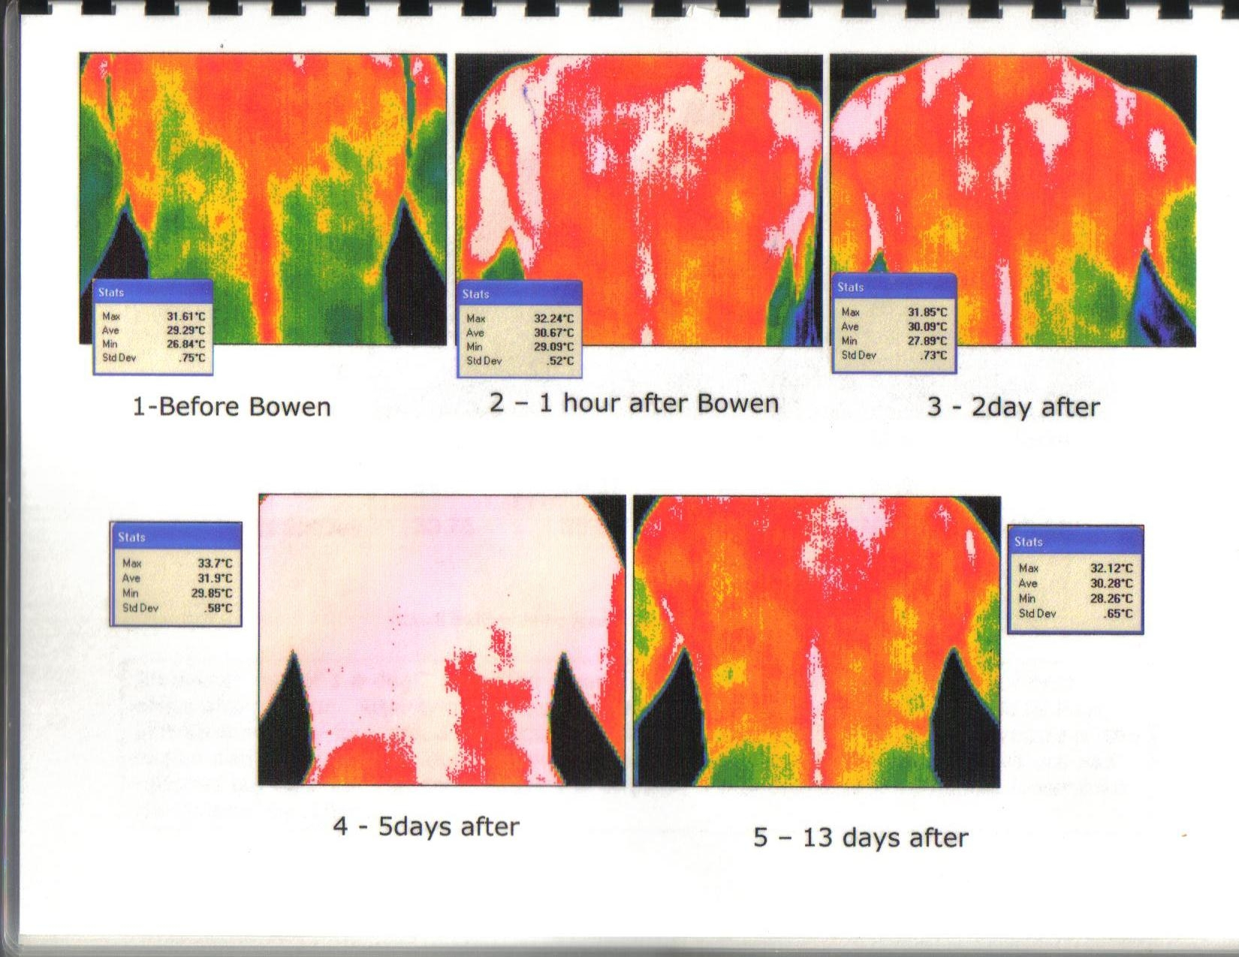

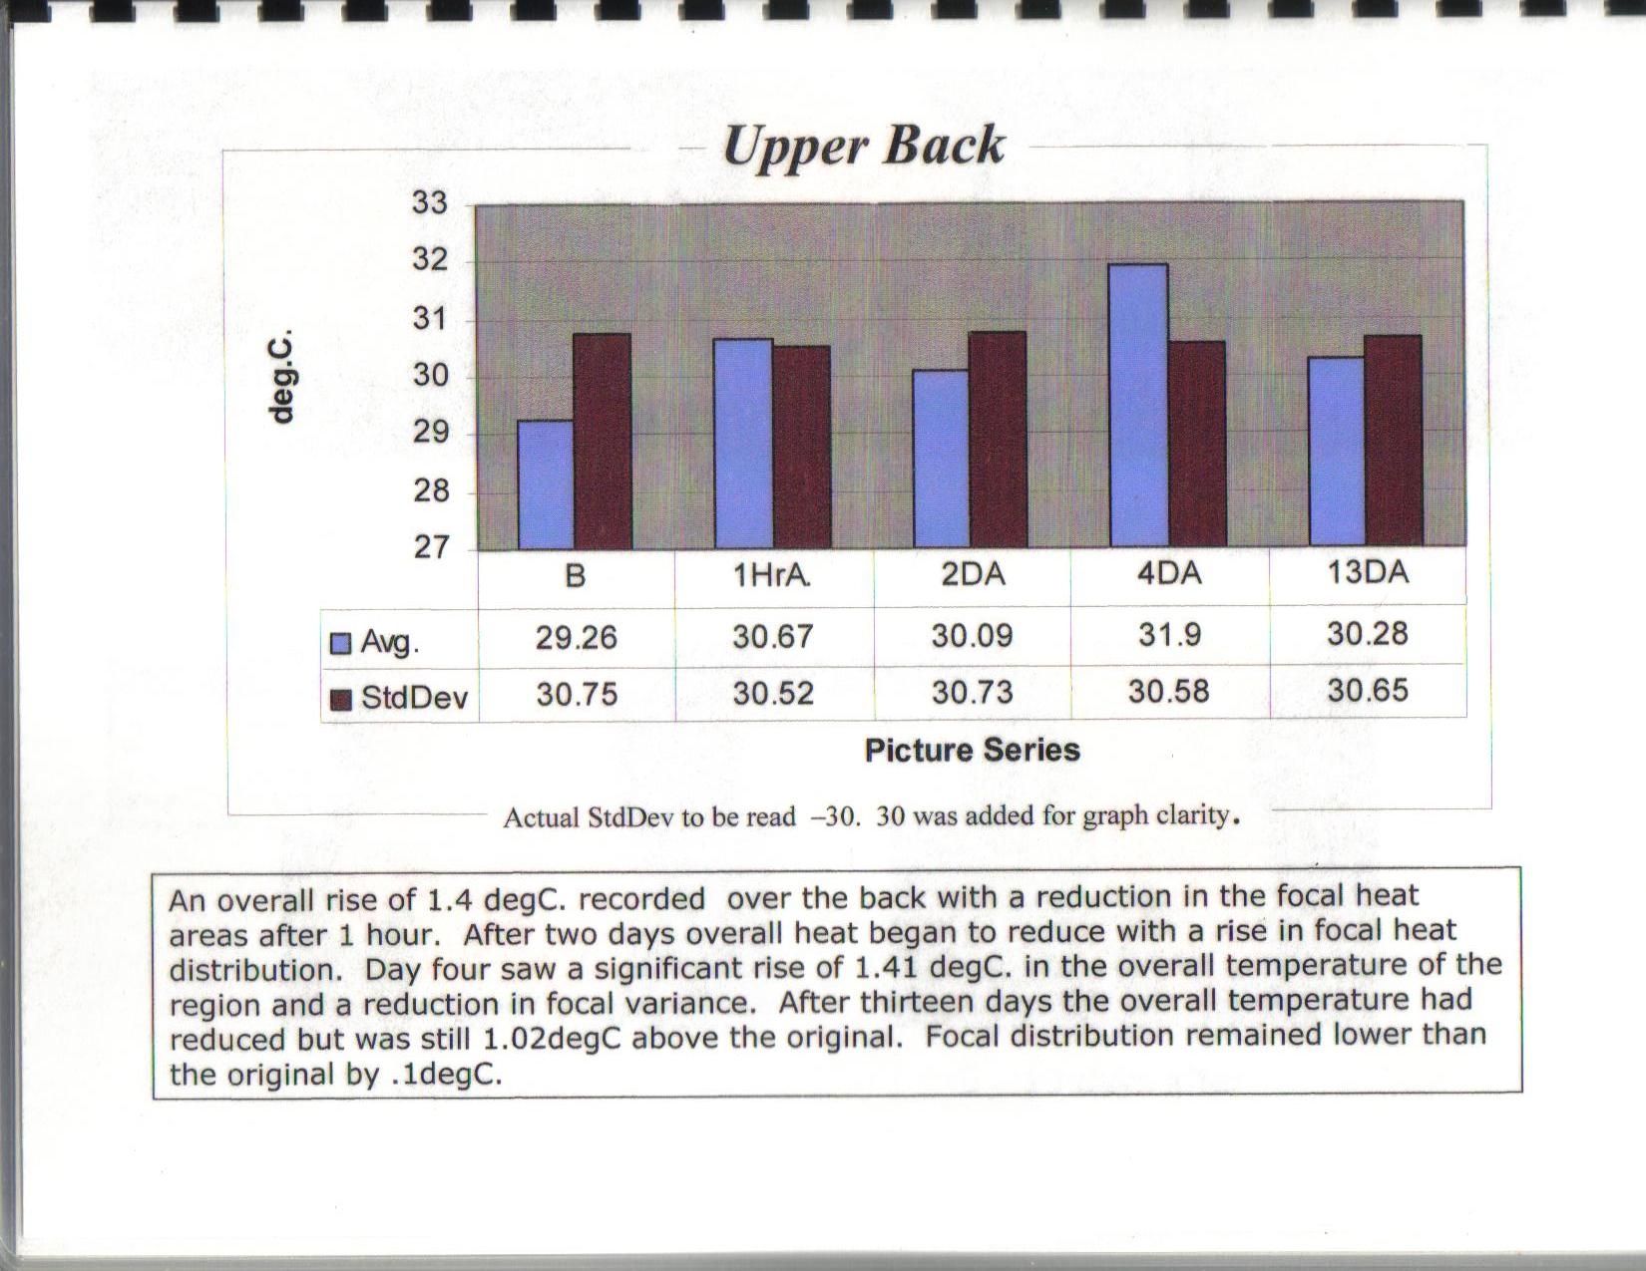

Subject 1. Head & Neck
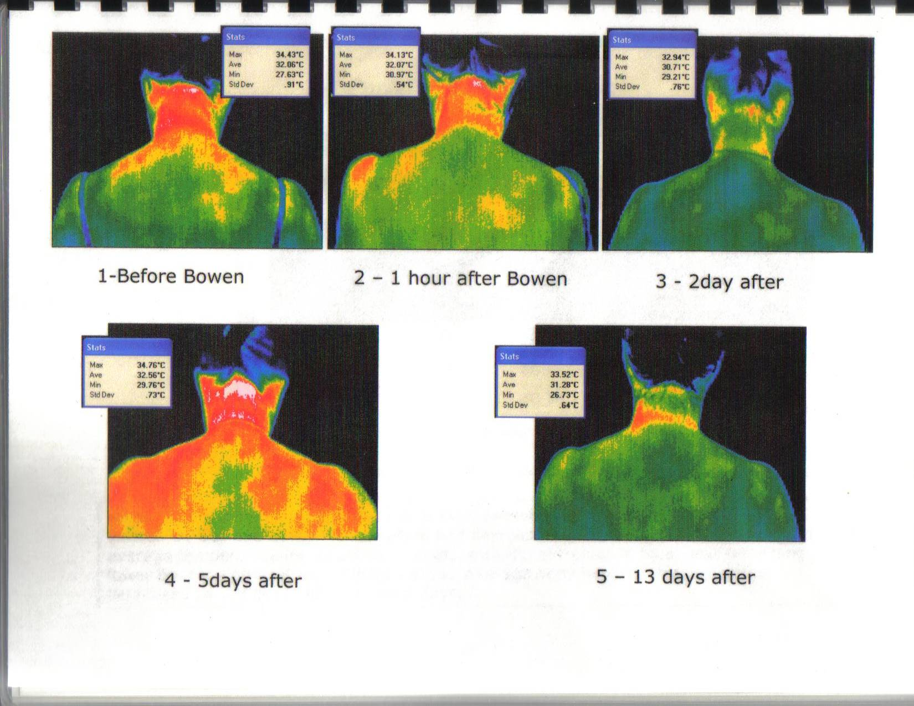

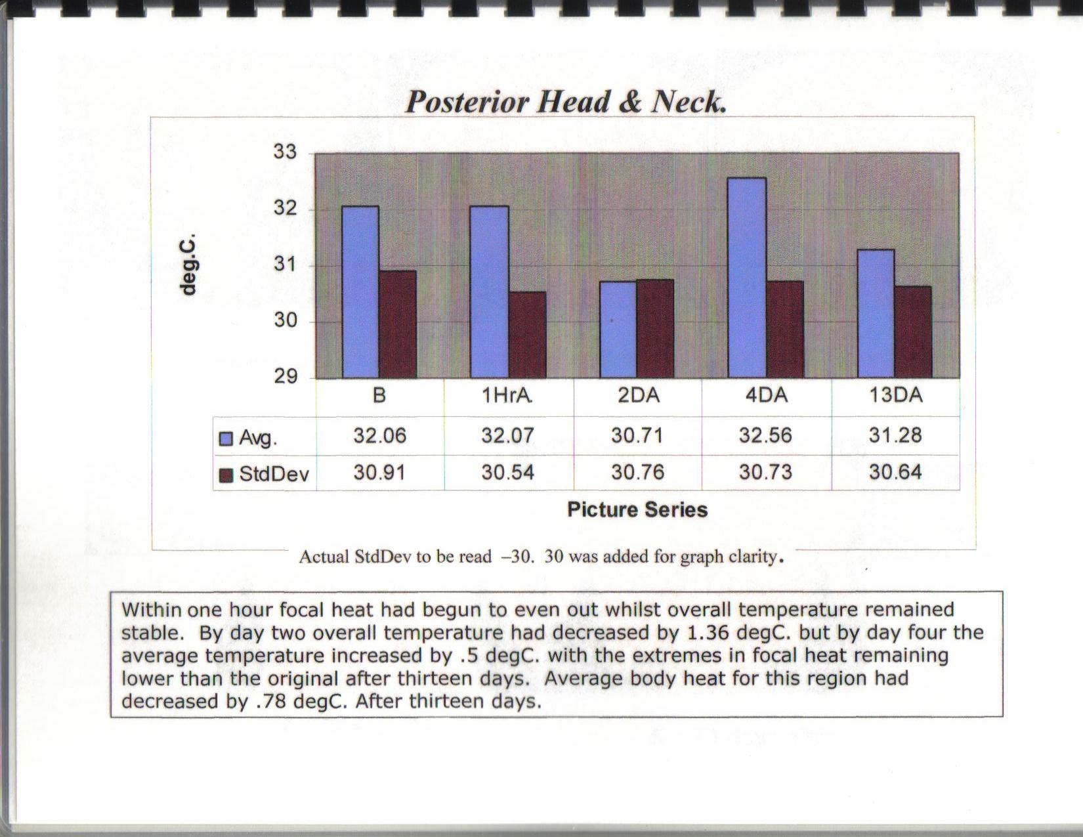

Subject 2. Back.

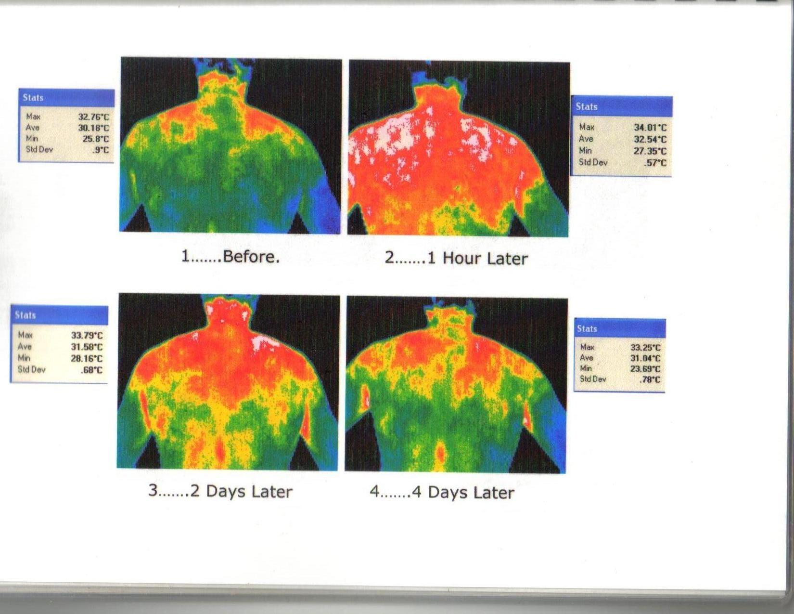

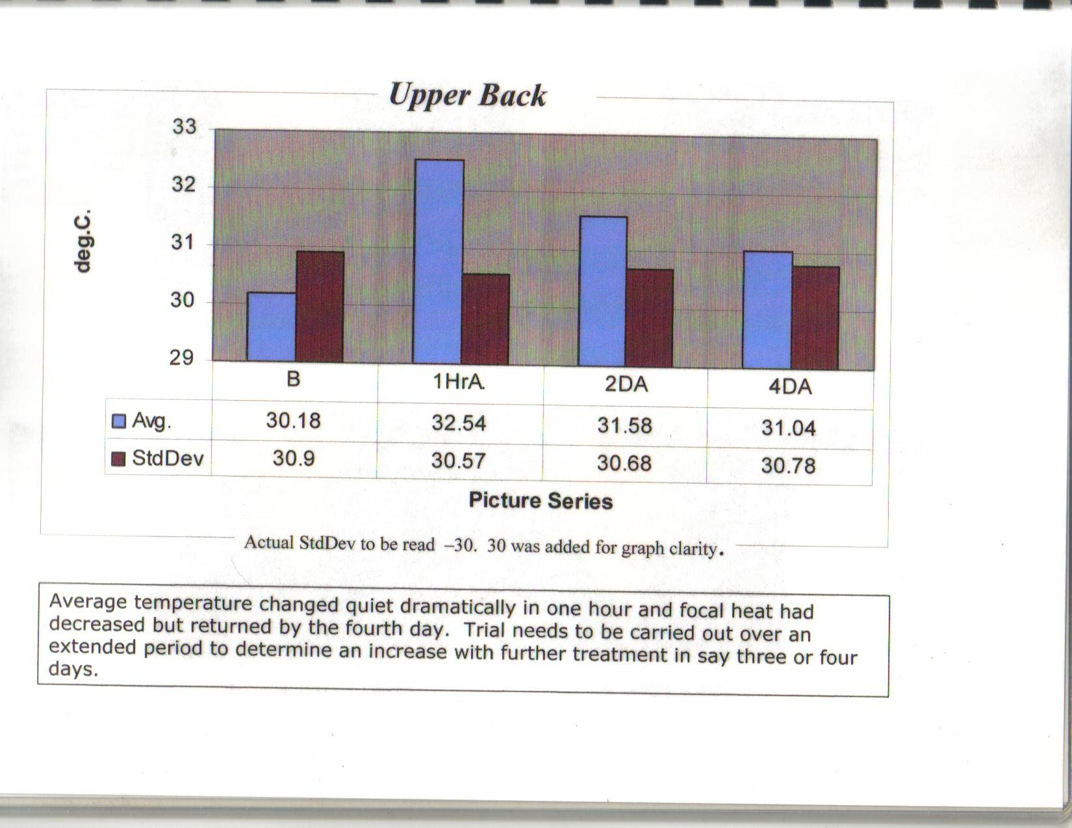

A Bowen move activates proprioceptors at multiple tissue levels, creating a dynamic re-arrangement of the Central and Peripheral Nervous System, leading to Postural Realignment, regulation of the Autonomic Nervous System, Fascial Release and ultimately facilitates the body in accessing its intrinsic ability to heal itself.

Border College of Natural Therapies.- Diploma of Bowen Therapy, Module 10, version 3 January 2008.

Ethical Considerations

Each participant fully understood the method and purpose of participating in this project.

Sharing knowledge.

I believe this therapy is an important breakthrough in discovering how the body responds to a Bowen therapy treatment for all health care professionals. It also shows the client/patient one of the ways their body is responding to this treatment.

Many people have ‘said’ just how bowen therapy works and why, and medical infrared thermal imaging is one method that reveals the changes in the skin temperature of the body when treated with Bowen Therapy.

These examples can be used to educate students.

Referemces

Australian workplace Thermal Testing, 2003
www.awtt.com.au/thermalimaging.html

Resh,RE. NeuralScan-a window into the spine. Unpublished brief, 1992

Dr Robert Kane, International Academy of Clinical Thermology.
www.flirthermography.com/media 2008

Gene Dobkin A Bowen Home Companion (Vol. 2) 2998, 1999. Publisher – U.S. Bowen, 1,c.,

Graham Baillie – Bowtec Bowen Therapy Technique Trial Using Digital Infrared Thermal Imaging – 2005.

Simon EK. Temperature regulation-spinal cord as a site of extrahypothalamac thermoregulation functions. Reviews of Psysiology,l Biochemistry and Pharmacology 1975;71:1-76.

Graham Baillie, Thermographer, unpublished Bowtech Bowen Therapy Trial, 2005

Photos by permission of Graham Baillie, Sunstate Thermal Imaging, Hervey Bay. Email: weseepain@bigpond.com

